
Company
Logotype

Cone Beam Computed Tomography- Report



Porur Dental X-rays & CBCT

Patient Name : Mrs. Sara | Date of Report : 05.07.2024
Age/ Gender : 38 years/ Female | Region of Interest : CBCT Sectional Mandible
Referring doctor: Denplant Dental Care | Indication : Implant assessment
Clinical Notes: Nil
PATIENT INFORMATION

CBCT- Sectional Mandible provided
CBCT – IMAGE DETAILS

RADIOGRAPHIC INTERPRETATION

- Complete loss of crown and root structure in relation to 37.
- Presence of hyperdense screw like structures (dental implant) in relation to 36 region.
- The alveolar bone in relation to 36, 37 is present with normal trabecular pattern.
- The implant in relation to 36 region is present at a distance of 6.51 mm from the inferior alveolar nerve canal; buccal bone present: 2.45 mm; lingual bone present: 1.85 mm

IMPLANT ASSESSMENT

 | 37 region
Sub-Crestal (in mm) | 6.72
Mid- Crestal (in mm) | 9.7
Distance between alveolar ridge and the inferior alveolar nerve canal (in mm) | 12.72
Distance between alveolar ridge and the inferior border of mandible (in mm) | 24.66

RADIOGRAPHIC IMPRESSION

- Implant in relation to 36 region.
- Partially edentulous region: 37.

Kindly correlate with clinical findings


IMAGES FOR REFERENCE

RECONSTRUCTED PANORAMIC VIEW

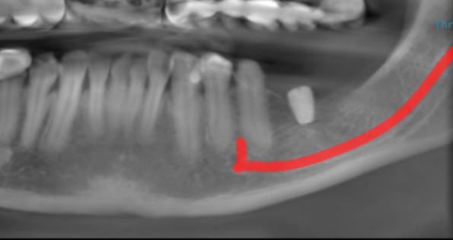

3-DIMENSIONAL VIEW

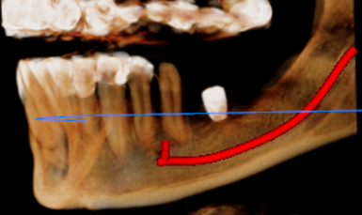

CROSS SECTIONAL VIEW

36 region | 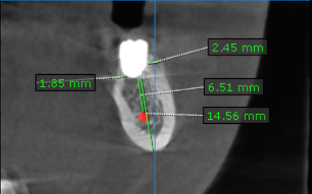
37 region | 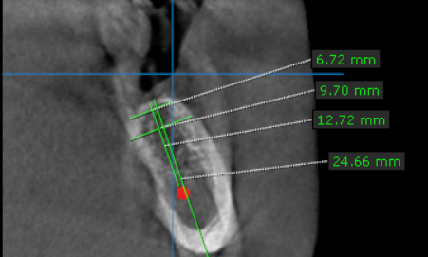

**** End of report ****

